CS-360-T5539 Mobile Architect & Programming 23EW5

6-3 Assignment - SensorManager

Jacob Simmons, 11 Jun 2023

This app uses the built-in light sensor to display text based on the input from ambient conditions. The "activity_mail.xml" file houses the code for the text to be displayed and then the code for the sensor input is stored in the MainActivity.kt java file. The sensor object is created and then it is used throughout the code to change based on the light input from the device. It will display a very bright condition with the sensor reading and then the dark reading (low numbers) as well as a message that states that it is a low or dark reading as shown below.

The purpose of SensorManager in Android Studio is to access the device’s sensors and connect them to the application. The sensors are a way for the user to interact with their surroundings and it’s a way for the environment to input into the device and interact with the user's experience. The sensors allow a new level of communication. This class first creates an instance of the sensor service. Then lists the sensor(s) that are being used. To detect changes, it incorporates event listeners which can tell the application about accuracy of the sensor and any changes in the values of the sensor.

Android have many different sensors that have many different uses and can be connected to a multitude of different applications. The sensors can be broken into three main categories which include motion sensors, environmental sensors, and position sensors.

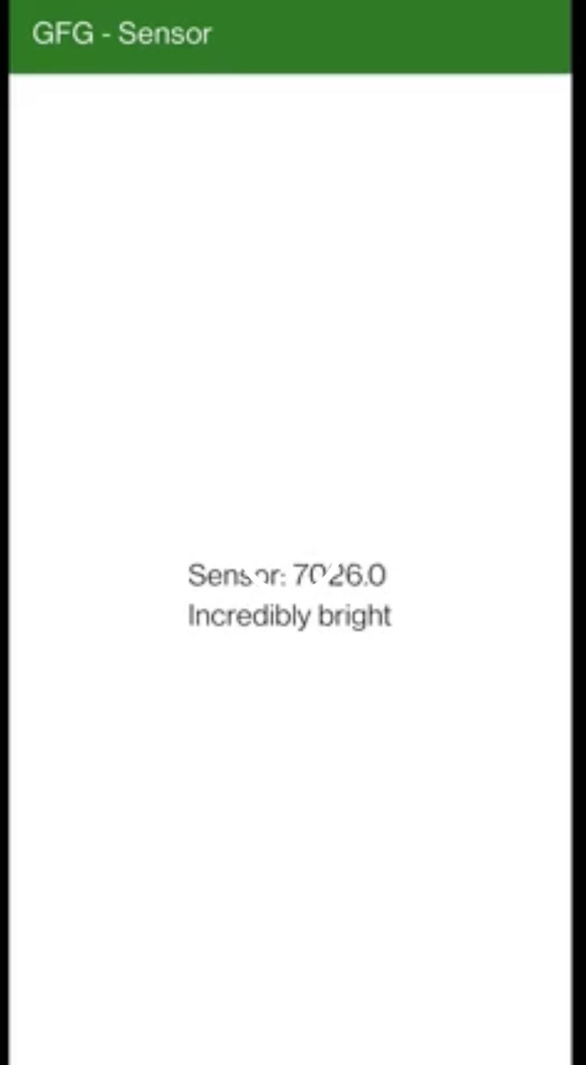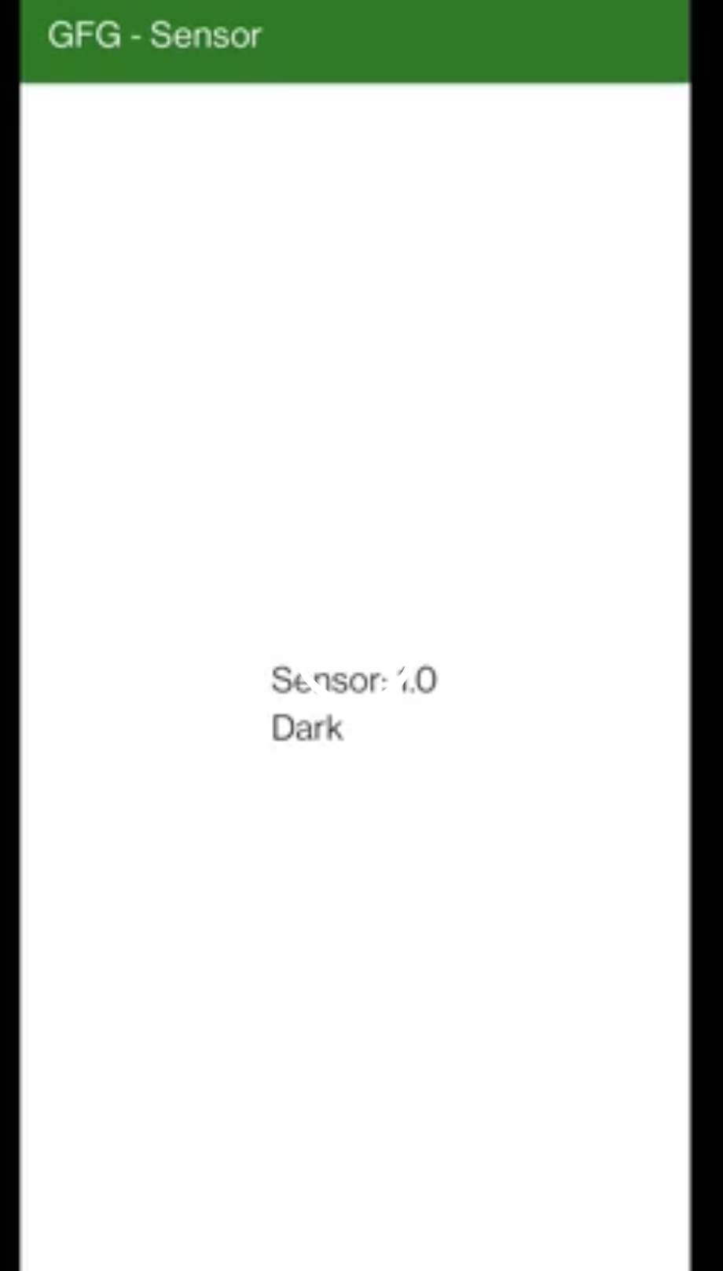

**References**